Predictive Parsing

RA1811003010344

VIKASH MISHRA

**COMPILER DESIGN LAB - 6**

AIM - Predictive Parsing

STATEMENT - Code which takes the number of productions and a regular grammar as input and generates the FirstPos , and follow of the non-terminal and displays its corresponding LL(1) parsing table.

ALOGRITHM -

(1) buffer: an input buffer which contains the string to be passed

(2) stack: a pushdown stack which contains a sequence of grammar symbols

(3) A parsing table: a 2d array M[A, a]

where

A->non-terminal, a->terminal or $

(4) output stream:

end of the stack and an end of the input symbols are both denoted with $

CODE -

#include<stdio.h>

#include<ctype.h>

#include<string.h>

void followfirst(char , int , int);

void findfirst(char , int , int);

void follow(char c);

int count,n=0;

char calc_first[10][100];

char calc_follow[10][100];

int m=0;

char production[10][10], first[10];

char f[10];

int k;

char ck;

int e;

int main(int argc,char **argv)

{

int jm=0;

int km=0;

int i,choice;

char c,ch;

printf("How many productions ? :");

scanf("%d",&count);

printf("\nEnter %d productions in form A=B where A and B are grammar symbols :\n\n",count);

for(i=0;i<count;i++)

{

scanf("%s%c",production[i],&ch);

}

int kay;

char done[count];

int ptr = -1;

for(k=0;k<count;k++){

for(kay=0;kay<100;kay++){

calc_first[k][kay] = '!';

}

}

int point1 = 0,point2,xxx;

for(k=0;k<count;k++)

{

c=production[k][0];

point2 = 0;

xxx = 0;

for(kay = 0; kay <= ptr; kay++)

if(c == done[kay])

xxx = 1;

if (xxx == 1)

continue;

findfirst(c,0,0);

ptr+=1;

done[ptr] = c;

printf("\n First(%c)= { ",c);

calc_first[point1][point2++] = c;

for(i=0+jm;i<n;i++){

int lark = 0,chk = 0;

for(lark=0;lark<point2;lark++){

if (first[i] == calc_first[point1][lark]){

chk = 1;

break;

}

}

if(chk == 0){

printf("%c, ",first[i]);

calc_first[point1][point2++] = first[i];

}

}

printf("}\n");

jm=n;

point1++;

}

printf("\n");

printf("-----------------------------------------------\n\n");

char donee[count];

ptr = -1;

for(k=0;k<count;k++){

for(kay=0;kay<100;kay++){

calc_follow[k][kay] = '!';

}

}

point1 = 0;

int land = 0;

for(e=0;e<count;e++)

{

ck=production[e][0];

point2 = 0;

xxx = 0;

for(kay = 0; kay <= ptr; kay++)

if(ck == donee[kay])

xxx = 1;

if (xxx == 1)

continue;

land += 1;

follow(ck);

ptr+=1;

donee[ptr] = ck;

printf(" Follow(%c) = { ",ck);

calc_follow[point1][point2++] = ck;

for(i=0+km;i<m;i++){

int lark = 0,chk = 0;

for(lark=0;lark<point2;lark++){

if (f[i] == calc_follow[point1][lark]){

chk = 1;

break;

}

}

if(chk == 0){

printf("%c, ",f[i]);

calc_follow[point1][point2++] = f[i];

}

}

printf(" }\n\n");

km=m;

point1++;

}

char ter[10];

for(k=0;k<10;k++){

ter[k] = '!';

}

int ap,vp,sid = 0;

for(k=0;k<count;k++){

for(kay=0;kay<count;kay++){

if(!isupper(production[k][kay]) && production[k][kay]!= '#' && production[k][kay] != '=' && production[k][kay] != '\0'){

vp = 0;

for(ap = 0;ap < sid; ap++){

if(production[k][kay] == ter[ap]){

vp = 1;

break;

}

}

if(vp == 0){

ter[sid] = production[k][kay];

sid ++;

}

}

}

}

ter[sid] = '$';

sid++;

printf("\n\t\t\t\t\t\t\t The LL(1) Parsing Table for the above grammer :-");

printf("\n\t\t\t\t\t\t\t^^^^^^^^^^^^^^^^^^^^^^^^^^^^^^^^^^^^^^^^^^^^^^^^^^\n");

printf("\n\t\t\t=====================================================================================================================\n");

printf("\t\t\t\t|\t");

for(ap = 0;ap < sid; ap++){

printf("%c\t\t",ter[ap]);

}

printf("\n\t\t\t=====================================================================================================================\n");

char first_prod[count][sid];

for(ap=0;ap<count;ap++){

int destiny = 0;

k = 2;

int ct = 0;

char tem[100];

while(production[ap][k] != '\0'){

if(!isupper(production[ap][k])){

tem[ct++] = production[ap][k];

tem[ct++] = '_';

tem[ct++] = '\0';

k++;

break;

}

else{

int zap=0;

int tuna = 0;

for(zap=0;zap<count;zap++){

if(calc_first[zap][0] == production[ap][k]){

for(tuna=1;tuna<100;tuna++){

if(calc_first[zap][tuna] != '!'){

tem[ct++] = calc_first[zap][tuna];

}

else

break;

}

break;

}

}

tem[ct++] = '_';

}

k++;

}

int zap = 0,tuna;

for(tuna = 0;tuna<ct;tuna++){

if(tem[tuna] == '#'){

zap = 1;

}

else if(tem[tuna] == '_'){

if(zap == 1){

zap = 0;

}

else

break;

}

else{

first_prod[ap][destiny++] = tem[tuna];

}

}

}

char table[land][sid+1];

ptr = -1;

for(ap = 0; ap < land ; ap++){

for(kay = 0; kay < (sid + 1) ; kay++){

table[ap][kay] = '!';

}

}

for(ap = 0; ap < count ; ap++){

ck = production[ap][0];

xxx = 0;

for(kay = 0; kay <= ptr; kay++)

if(ck == table[kay][0])

xxx = 1;

if (xxx == 1)

continue;

else{

ptr = ptr + 1;

table[ptr][0] = ck;

}

}

for(ap = 0; ap < count ; ap++){

int tuna = 0;

while(first_prod[ap][tuna] != '\0'){

int to,ni=0;

for(to=0;to<sid;to++){

if(first_prod[ap][tuna] == ter[to]){

ni = 1;

}

}

if(ni == 1){

char xz = production[ap][0];

int cz=0;

while(table[cz][0] != xz){

cz = cz + 1;

}

int vz=0;

while(ter[vz] != first_prod[ap][tuna]){

vz = vz + 1;

}

table[cz][vz+1] = (char)(ap + 65);

}

tuna++;

}

}

for(k=0;k<sid;k++){

for(kay=0;kay<100;kay++){

if(calc_first[k][kay] == '!'){

break;

}

else if(calc_first[k][kay] == '#'){

int fz = 1;

while(calc_follow[k][fz] != '!'){

char xz = production[k][0];

int cz=0;

while(table[cz][0] != xz){

cz = cz + 1;

}

int vz=0;

while(ter[vz] != calc_follow[k][fz]){

vz = vz + 1;

}

table[k][vz+1] = '#';

fz++;

}

break;

}

}

}

for(ap = 0; ap < land ; ap++){

printf("\t\t\t %c\t|\t",table[ap][0]);

for(kay = 1; kay < (sid + 1) ; kay++){

if(table[ap][kay] == '!')

printf("\t\t");

else if(table[ap][kay] == '#')

printf("%c=#\t\t",table[ap][0]);

else{

int mum = (int)(table[ap][kay]);

mum -= 65;

printf("%s\t\t",production[mum]);

}

}

printf("\n");

printf("\t\t\t---------------------------------------------------------------------------------------------------------------------");

printf("\n");

}

int j;

printf("\n\nPlease enter the desired INPUT STRING = ");

char input[100];

scanf("%s%c",input,&ch);

printf("\n\t\t\t\t\t===========================================================================\n");

printf("\t\t\t\t\t\tStack\t\t\tInput\t\t\tAction");

printf("\n\t\t\t\t\t===========================================================================\n");

int i_ptr = 0,s_ptr = 1;

char stack[100];

stack[0] = '$';

stack[1] = table[0][0];

while(s_ptr != -1){

printf("\t\t\t\t\t\t");

int vamp = 0;

for(vamp=0;vamp<=s_ptr;vamp++){

printf("%c",stack[vamp]);

}

printf("\t\t\t");

vamp = i_ptr;

while(input[vamp] != '\0'){

printf("%c",input[vamp]);

vamp++;

}

printf("\t\t\t");

char her = input[i_ptr];

char him = stack[s_ptr];

s_ptr--;

if(!isupper(him)){

if(her == him){

i_ptr++;

printf("POP ACTION\n");

}

else{

printf("\nString Not Accepted by LL(1) Parser !!\n");

exit(0);

}

}

else{

for(i=0;i<sid;i++){

if(ter[i] == her)

break;

}

char produ[100];

for(j=0;j<land;j++){

if(him == table[j][0]){

if (table[j][i+1] == '#'){

printf("%c=#\n",table[j][0]);

produ[0] = '#';

produ[1] = '\0';

}

else if(table[j][i+1] != '!'){

int mum = (int)(table[j][i+1]);

mum -= 65;

strcpy(produ,production[mum]);

printf("%s\n",produ);

}

else{

printf("\nString Not Accepted by LL(1) Parser !!\n");

exit(0);

}

}

}

int le = strlen(produ);

le = le - 1;

if(le == 0){

continue;

}

for(j=le;j>=2;j--){

s_ptr++;

stack[s_ptr] = produ[j];

}

}

}

printf("\n\t\t\t=======================================================================================================================\n");

if (input[i_ptr] == '\0'){

printf("\t\t\t\t\t\t\t\tYOUR STRING HAS BEEN ACCEPTED !!\n");

}

else

printf("\n\t\t\t\t\t\t\t\tYOUR STRING HAS BEEN REJECTED !!\n");

printf("\t\t\t=======================================================================================================================\n");

}

void follow(char c)

{

int i ,j;

if(production[0][0]==c){

f[m++]='$';

}

for(i=0;i<10;i++)

{

for(j=2;j<10;j++)

{

if(production[i][j]==c)

{

if(production[i][j+1]!='\0'){

followfirst(production[i][j+1],i,(j+2));

}

if(production[i][j+1]=='\0'&&c!=production[i][0]){

follow(production[i][0]);

}

}

}

}

}

void findfirst(char c ,int q1 , int q2)

{

int j;

if(!(isupper(c))){

first[n++]=c;

}

for(j=0;j<count;j++)

{

if(production[j][0]==c)

{

if(production[j][2]=='#'){

if(production[q1][q2] == '\0')

first[n++]='#';

else if(production[q1][q2] != '\0' && (q1 != 0 || q2 != 0))

{

findfirst(production[q1][q2], q1, (q2+1));

}

else

first[n++]='#';

}

else if(!isupper(production[j][2])){

first[n++]=production[j][2];

}

else {

findfirst(production[j][2], j, 3);

}

}

}

}

void followfirst(char c, int c1 , int c2)

{

int k;

if(!(isupper(c)))

f[m++]=c;

else{

int i=0,j=1;

for(i=0;i<count;i++)

{

if(calc_first[i][0] == c)

break;

}

while(calc_first[i][j] != '!')

{

if(calc_first[i][j] != '#'){

f[m++] = calc_first[i][j];

}

else{

if(production[c1][c2] == '\0'){

follow(production[c1][0]);

}

else{

followfirst(production[c1][c2],c1,c2+1);

}

}

j++;

}

}

}

INPUT -

8

E=TR

R=+TR

R=#

T=FY

Y=*FY

Y=#

F=(E)

F=I

OUTPUT -

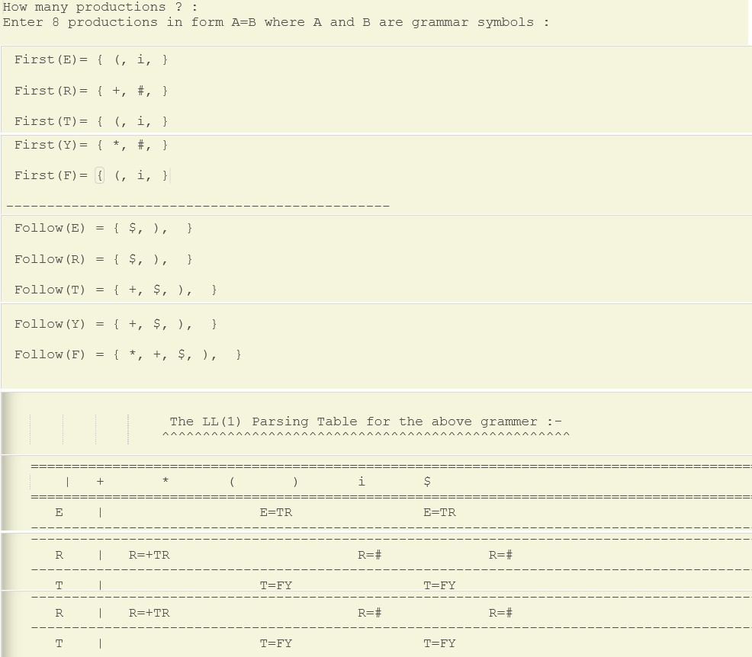

RESULT -

Predictive Parsing program was successfully executed.